Beaver Scouts

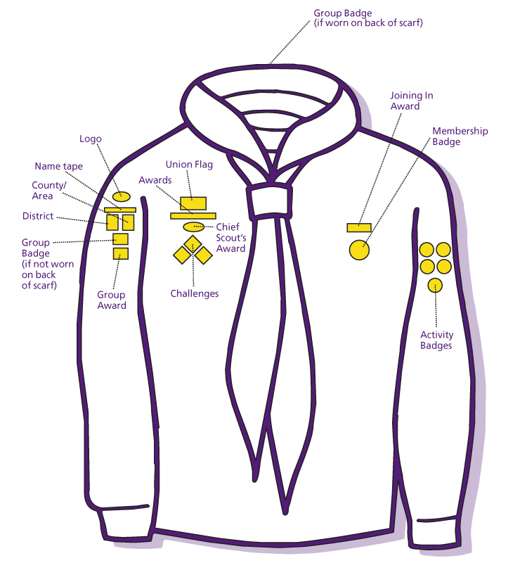
Rhondda Badge
Mid Glamorgan Badge

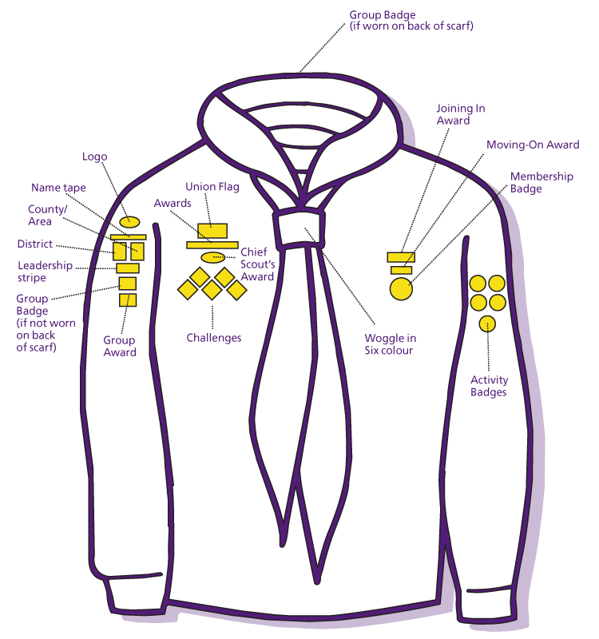
Cub Scouts

Rhondda Badge
Mid Glamorgan Badge

Dragons go on the shoulder with the Dragons head facing front ways
Scouts

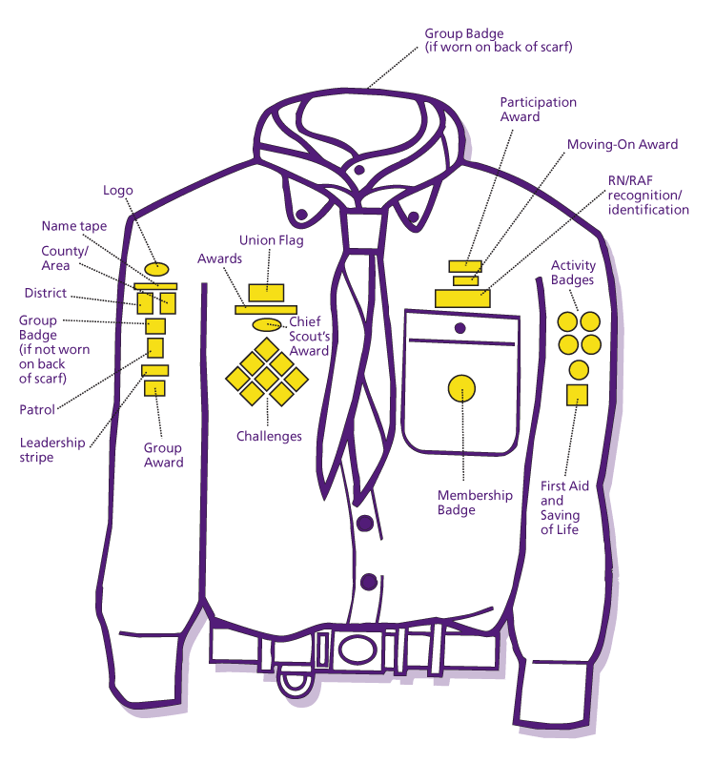
Mid Glamorgan Badge
Rhondda Badge
Dragons go on the shoulder with the Dragons head facing front ways

