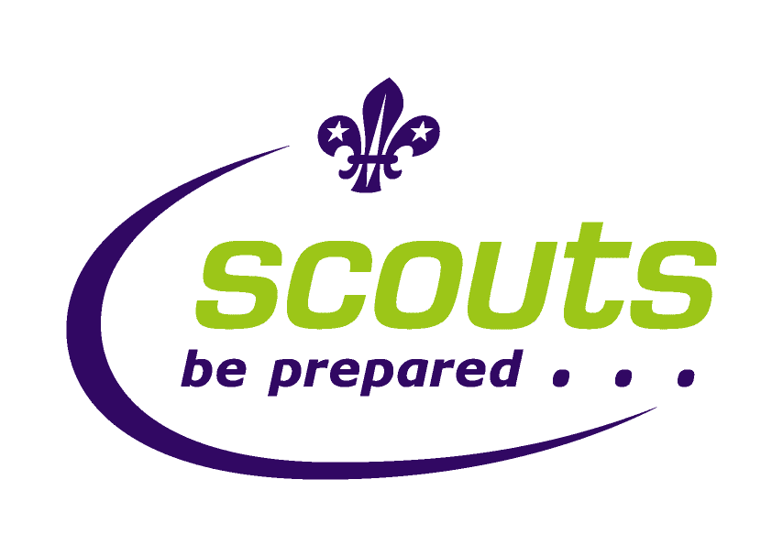
1st Pontygwaith Scout Group
Photograph permission form

Dear Parent/Guardian,

From time to time there may be photographs or video footage taken of your son/daughter during their time in the Scout Group. We would like to ask for your permission should the need arise to use these photographs/video footage for scouting purposes only and publish these on our website.

This request is a requirement to ensure that you as parents/guardians are fully aware and are happy for photographs and video footage to be taken and used to promote the Group. Publication of any photographs/video footage will be published using guidelines lines issued by the Scout Association. Details of the guidelines can be found on our website.

Therefore if you could acknowledge your consent by completing the slip below, it would be much appreciated. This will be taken as an indefinite consent unless we are informed otherwise.

Regards,

John Webber
1st Pontygwaith Scout Group.



I have read the above information regarding the taking of photographs and video footage and give my permission for photographs and video footage of my son/daughter (name of young person) …………………………….. to be taken whilst undertaking scouting activities and give consent for you to use these for promoting the scout group.

Signed: ………………………………… Date: ………………………

